AUCSC 218 – LAB Assignment

Difficulty Level: Intermediate

Overview

You will demonstrate your ability to use the DOM and to handle events using both event delegation and “regular” event handling.

**You can work individually or in groups of up to three students**

Instructions

1. Examine chapter09-project02.html. You will add event handlers to the thumbnail images and to the larger image. You will not need to make any changes to the supplied markup or CSS.
2. All of your event handlers must execute only after the page has loaded.
3. You are going to add a click event handler to each of the thumbnail images. When the smaller image is clicked, your code will show the larger version of the image in the <img> element within the <figure> element. This same event handler will also set the <figcaption> text of the <figure> to the clicked thumbnail image's title attribute. Your event handler must use event delegation (i.e., the click event handler will be attached to the <div id=“thumbnails”> element and not to the individual <img> elements).
4. You must also add event handlers to the mouseover and mouseout events of the <figure> element. When the user moves the mouse over the larger image, then you will fade the <figcaption> element to about 80% opacity (its initial CSS opacity is 0% or transparent/invisible). When the user moves the mouse out of the figure, then fade the <figcaption> back to 0% opacity. You can set the opacity of an element in JavaScript by setting its style .opacity property.
5. You can animate (for instance, a fade is an animation) any CSS setting (such as opacity) in JavaScript by setting its style.transition property. For instance, in JavaScript, setting an object's transition style property to “opacity 1s” tells the browser to transition the opacity to its next setting across one second.

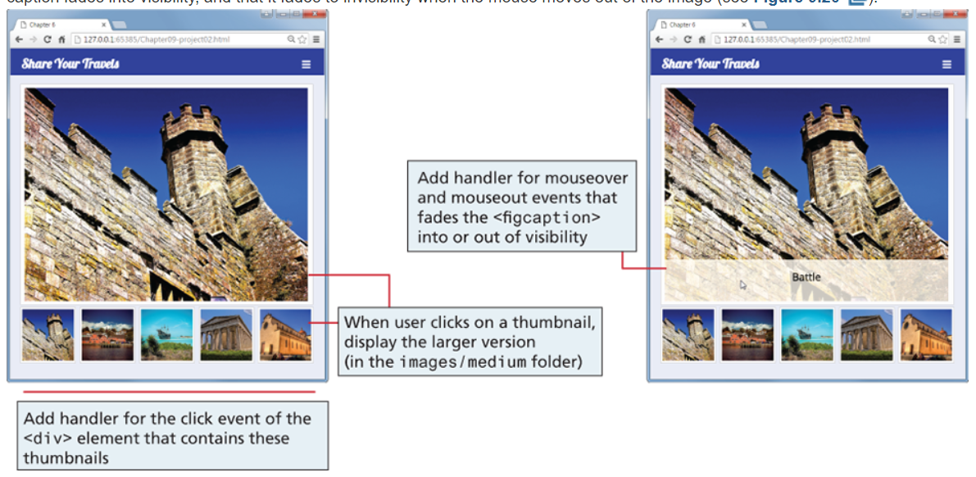

Test

1. Verify the page changes the larger image when you click on a thumbnail. Hover the mouse over the large image to verify that the caption fades into visibility, and that it fades to invisibility when the mouse moves out of the image

Submit

Zip the entire folder named assign2_name1_name2_name3, include all resources required to run the project and submit it to eClass